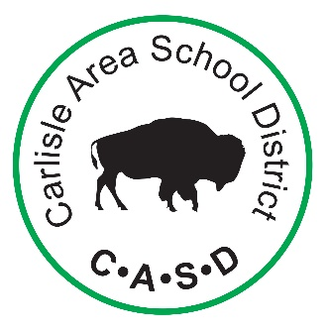
DISTRICT HEALTH COUNCIL
2019-2020

Building | Name | Affiliation
District Administration | Michael Gogoj | Director of Curriculum and Instruction
School Board | Anne Lauritzen | Board Member
Bellaire Elementary | Julie Reichard | Nurse
Crestview Elementary | Elaine Rampulla | Nurse
Hamilton Elementary | Terri Vaupel | Nurse
LeTort Elementary | Aaron Carmichael  Kerri Wheeler | Principal  Nurse
Mooreland Elementary | Amanda Fair  Barb Wohlgemuth | Teacher  Teacher
Mt. Holly Springs Elementary | Emily Fuller | Teacher
North Dickinson Elementary | Anna Ellis  Brian Gochenour | Nurse  Principal
Wilson Middle School | Bonnie Kirk | Teacher – Health/PE
Lamberton Middle School | Rossalyn Vanderlyke | Teacher – Health
Carlisle High School | Lynne Kline  Diane Lello | Teacher – Health/PE  Nurse
Chartwells | Gail Hurley | Food Service Director
Partnership for Better Health | Carol Thornton | Community Member
Community | Holly Smith | Community Member

Required Representatives:
- School board members
- District administrator
- Food service director
- Student
- Parent/Guardian
- School health professional
- Health teacher
- Physical Education teacher
- Member of the public

